**EXPERIMENT 06**

CLASS: BE CMPN A 2 ROLL NO. : 18

NAME: REBECCA DIAS PID: 182027

**Aim**: Study Infrastructure as a Service

**Theory:**

1. Prepare a detailed study of Infrastructure as a Service

Infrastructure as a service (IaaS) is a type of cloud computing service that offers essential compute, storage and networking resources on demand, on a pay-as-you-go basis. IaaS is one of the four types of cloud services, along with software as a service (SaaS), platform as a service (PaaS) and serverless.

Migrating your organisation's infrastructure to an IaaS solution helps you reduce maintenance of on-premises data centres, save money on hardware costs and gain real-time business insights. IaaS solutions give you the flexibility to scale your IT resources up and down with demand. They also help you quickly provision new applications and increase the reliability of your underlying infrastructure.

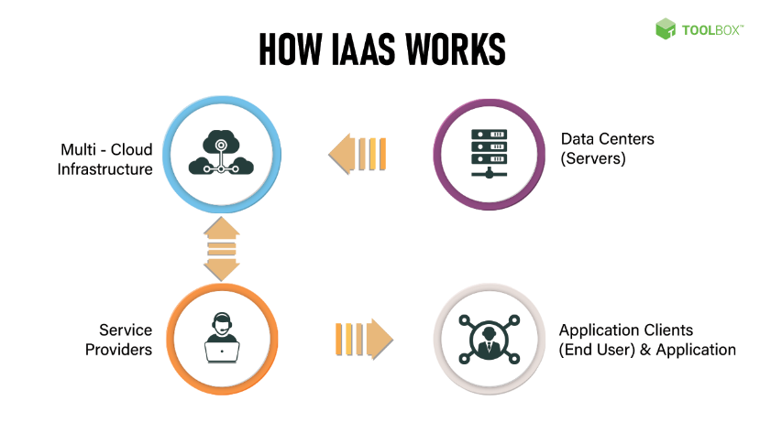

IaaS lets you bypass the cost and complexity of buying and managing physical servers and datacentre infrastructure. Each resource is offered as a separate service component and you only pay for a particular resource for as long as you need it. A cloud computing service provider like Azure manages the infrastructure, while you purchase, install, configure and manage your own software—including operating systems, middleware and applications.

Key features:

* Instead of purchasing hardware outright, users pay for IaaS on demand.
* Infrastructure is scalable depending on processing and storage needs.
* Saves enterprises the costs of buying and maintaining their own hardware.
* Because data is on the cloud, there can be no single point of failure.
* Enables the virtualization of administrative tasks, freeing up time for other work.

2. Advantages and Limitation of IaaS

*Advantages*:

1. Cost Effective

IaaS is most economical option for businesses since it eliminates the cost of infrastructure. There is no need to purchase hardware as well as other networking equipments. And also, IaaS follows pay-as-you-go pricing scheme. Meaning, the users must spend only for what they use. The expenses are involved only at monthly level.

2. Scalability

When scaling an IaaS solution, it does not require investment in the hardware. The reason for this is the presence of cloud resources in unlimited quantity. As per the company's requirement, the IaaS allows it to be scaled up and down. As a result, businesses can save time as well as money. Once the usage of services are over, the users could scale down the solution.

3. Reliability

Reliability of data in IaaS is present to a very high extent. It is able to recover from worst case scenarios. This is because the resources of IaaS is present across various servers. Even if one server encounters problems, the remaining servers could deliver the resources without disruptions.

Even if there is an internet connection failure, hardware failure or a disaster, the infrastructure could still continue to function. Therefore, in any outages the IaaS could recover instantly.

4. Accessibility

Work today require greatest amount of flexibility. Especially, when it comes to accessibility. IaaS allows employees of an organization to easily access their files and other documents instantly. Virtual offices are made available to the employees anytime as long as they are having an internet connection.

5. Business Productivity

Whenever the workload of a business increases, maintenance becomes difficult without more staffs. But in IaaS, there is no burden of training new staffs. Instead it is taken care by a third party service provider. IaaS provider is responsible of maintaining and upgrading the infrastructure. Hence, the management could focus on other business operations.

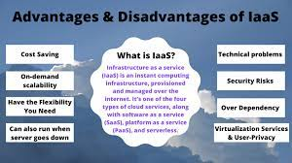

*Disadvantages:*

1. Security

Users in IaaS does not have the control of infrastructure. The security of the infrastructure is in the hands of the provider. Sometimes the level of security provided may not be adequate. As a result, it could expose your system to hacks and vulnerabilities. In this case, the businesses must be willing to accept the loss.

2. Control

The entire administration of the IaaS is taken care by the provider. While this could be a stress relief for the users, this can leave important part of controlling to the provider. Such as the users have no control over data and software. Under these conditions, the provider needs to make sure that the data as well as services are secure.

3. Customization

Customization is not an easy task in IaaS since it is based on virtualization services. This is because there is very less number of options for customization. As a result, the user privacy offered is not greater as it is with other solutions.

4. Upgradeability

Even though maintenance is provided by the IaaS providers, still they fail to provide upgrades for some businesses. Besides the hardware the IaaS provider is in charge of providing upgrades to the applications. Now the businesses without frequent upgrades to their software will face productivity issues since their employee efficiency is affected.

5. Technical Issues

Downtime is one of the most common technical issues faced when using IaaS solution. While the user data is spread across various data centers, still the issues that is faced from the providers end could restrict accessibility. Users will no longer will be able to access the applications and data which delays work that needs to be done.

3. Study security issues in IaaS

* Data Leaks

Data in the cloud is exposed to the same threats as traditional infrastructures. Due to the large amount of data, platforms of cloud providers become an attractive target for attackers. Data leaks can lead to a chain of unfortunate events for IT companies and infrastructure as a service (IaaS) providers.

* Compromising Accounts And Authentication Bypass

Data leaks often result from insufficient attention to authentication verification. More often than not, weak passwords in conjunction with poor management of encryption keys and certificates are to blame. In addition, IT organizations are faced with problems of managing rights and permissions when users are assigned with much greater powers than they actually need. The problem can also occur when a user takes another position or leaves the company: no one is in a rush to update permissions under the new user roles. As a result, the account has rights to more features than necessary.

* Interface And API Hacking

Today, it is impossible to imagine cloud services and applications without friendly user interfaces (UIs) and application program interfaces (APIs). The security and availability of cloud services depends on reliable mechanisms of data access control and encryption. Weak interfaces become bottlenecks in matters of availability, confidentiality, integrity and security of systems and data.

* Cyberattacks

Targeted cyberattacks are common in our times. An experienced attacker, who has secured his presence in a target infrastructure, is not so easy to detect. Remote network attacks may have significant impact on the availability of infrastructure in general.

Despite the fact that denial-of-service (DoS) attacks have a long history, the development of cloud computing has made them more common. DoS attacks can cause business critical services to slow down or even stop. DoS attacks consume a large amount of computing power that comes with a hefty bill. Despite the fact that the principles of DoS attacks are simple at first glance, you need to understand their characteristics at the application level: the focus on the vulnerability of web servers, databases and applications.

* Permanent Data Loss

Data loss due to malicious acts or accidents at the provider’s end is no less critical than a leak. Daily backups and their storage on external protected alternative platforms are particularly important for cloud environments.

In addition, if you are using encryption before moving data to the cloud, it is necessary to take care of secure storage for encryption keys. As soon as keys fall into the wrong hands, data itself becomes available to attackers, the loss of which can wreak havoc on any organization.

* Vulnerabilities

A common mistake when using cloud-based solutions in the IaaS model is paying too little attention to the security of applications, which are placed in the secure infrastructure of the cloud provider. And the vulnerability of applications becomes a bottleneck in enterprise infrastructure security.

* Lack Of Awareness

Organizations moving to the cloud without understanding the capabilities the cloud has to offer are faced with many problems. If a team of specialists is not very familiar with the features of cloud technologies and principles of deploying cloud-based applications, operational and architectural issues arise that can lead not only to downtime but also to much more serious problems.

* Abuse Of Cloud Services

The cloud can be used by legal and illegal businesses. The purpose of the latter is to use cloud resources for criminal activity: launching DoS attacks, sending spam, distributing malicious content, etc. It is extremely important for suppliers and service users to be able to detect such activities. To do this, detailed traffic inspections and cloud monitoring tools are recommended.

**Activity:**

1. Use AWS, to create a VM and configure it.
2. Access the created machine remotely

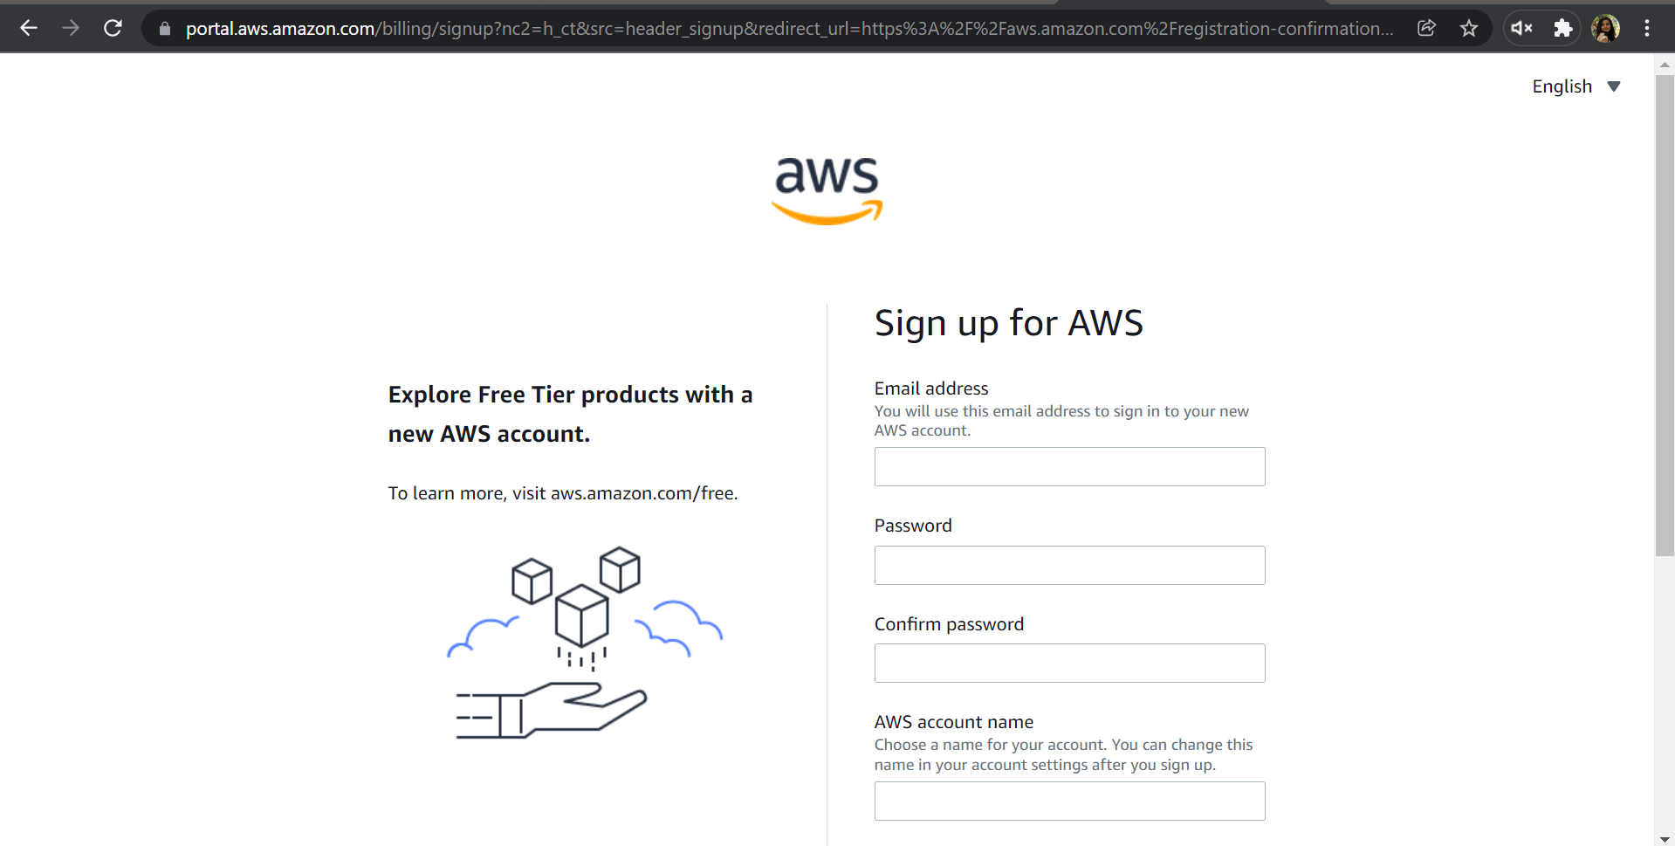

1.To demonstrate and implement IAAS service using AWS (Use t2.Micro (Free tier eligible) (instance only).

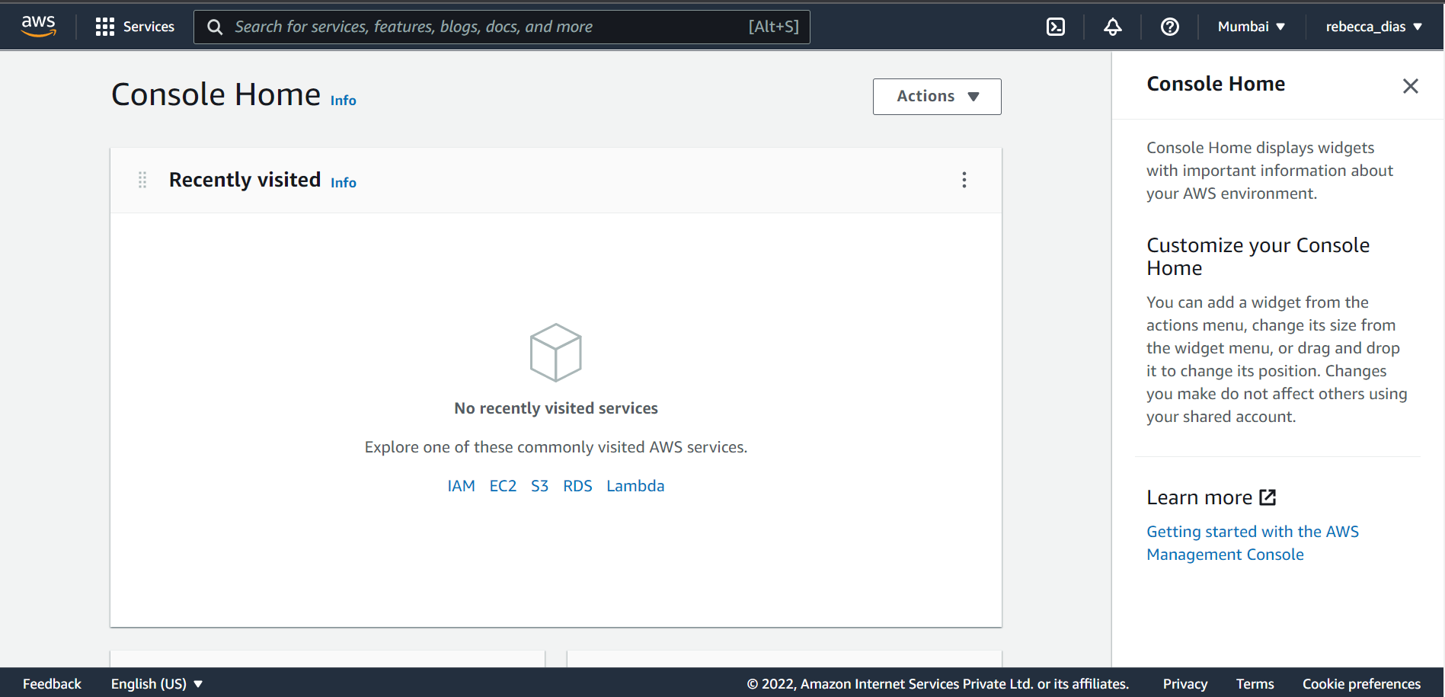

Choose Msft windows server base 2019

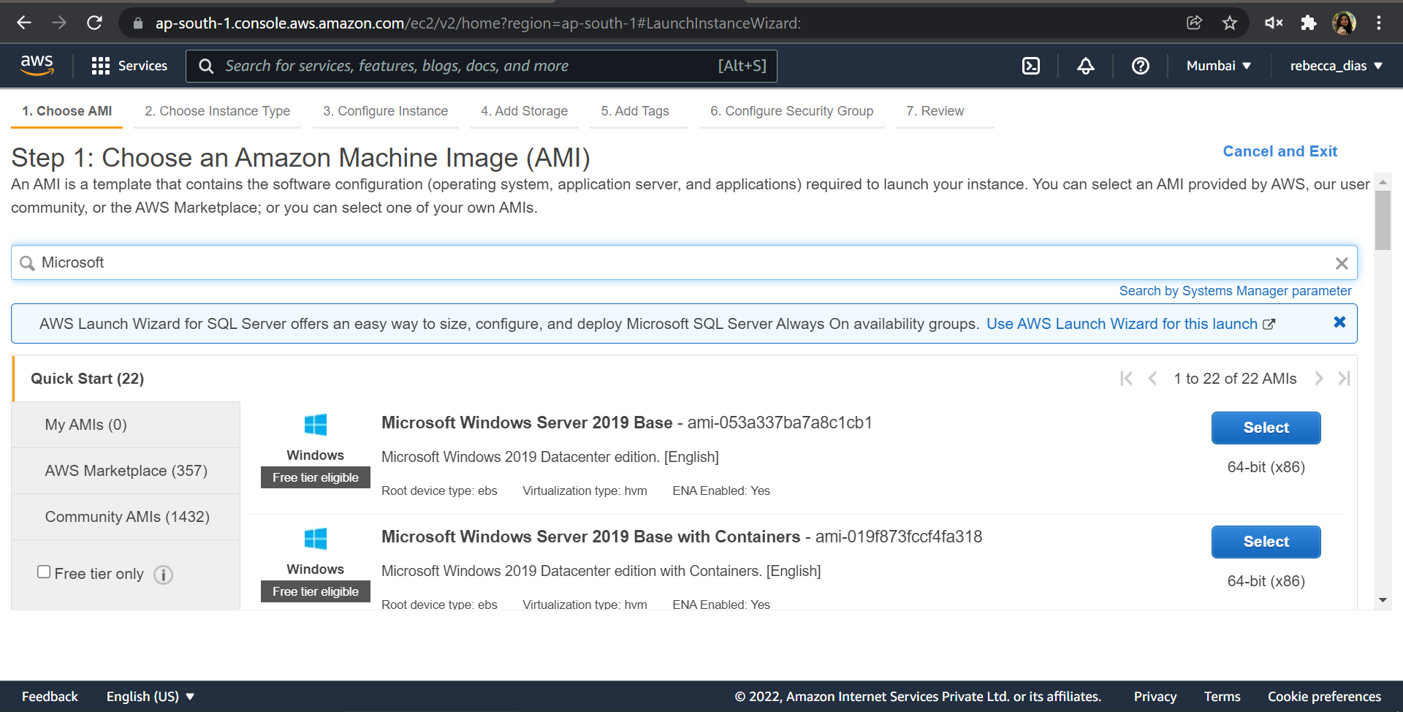

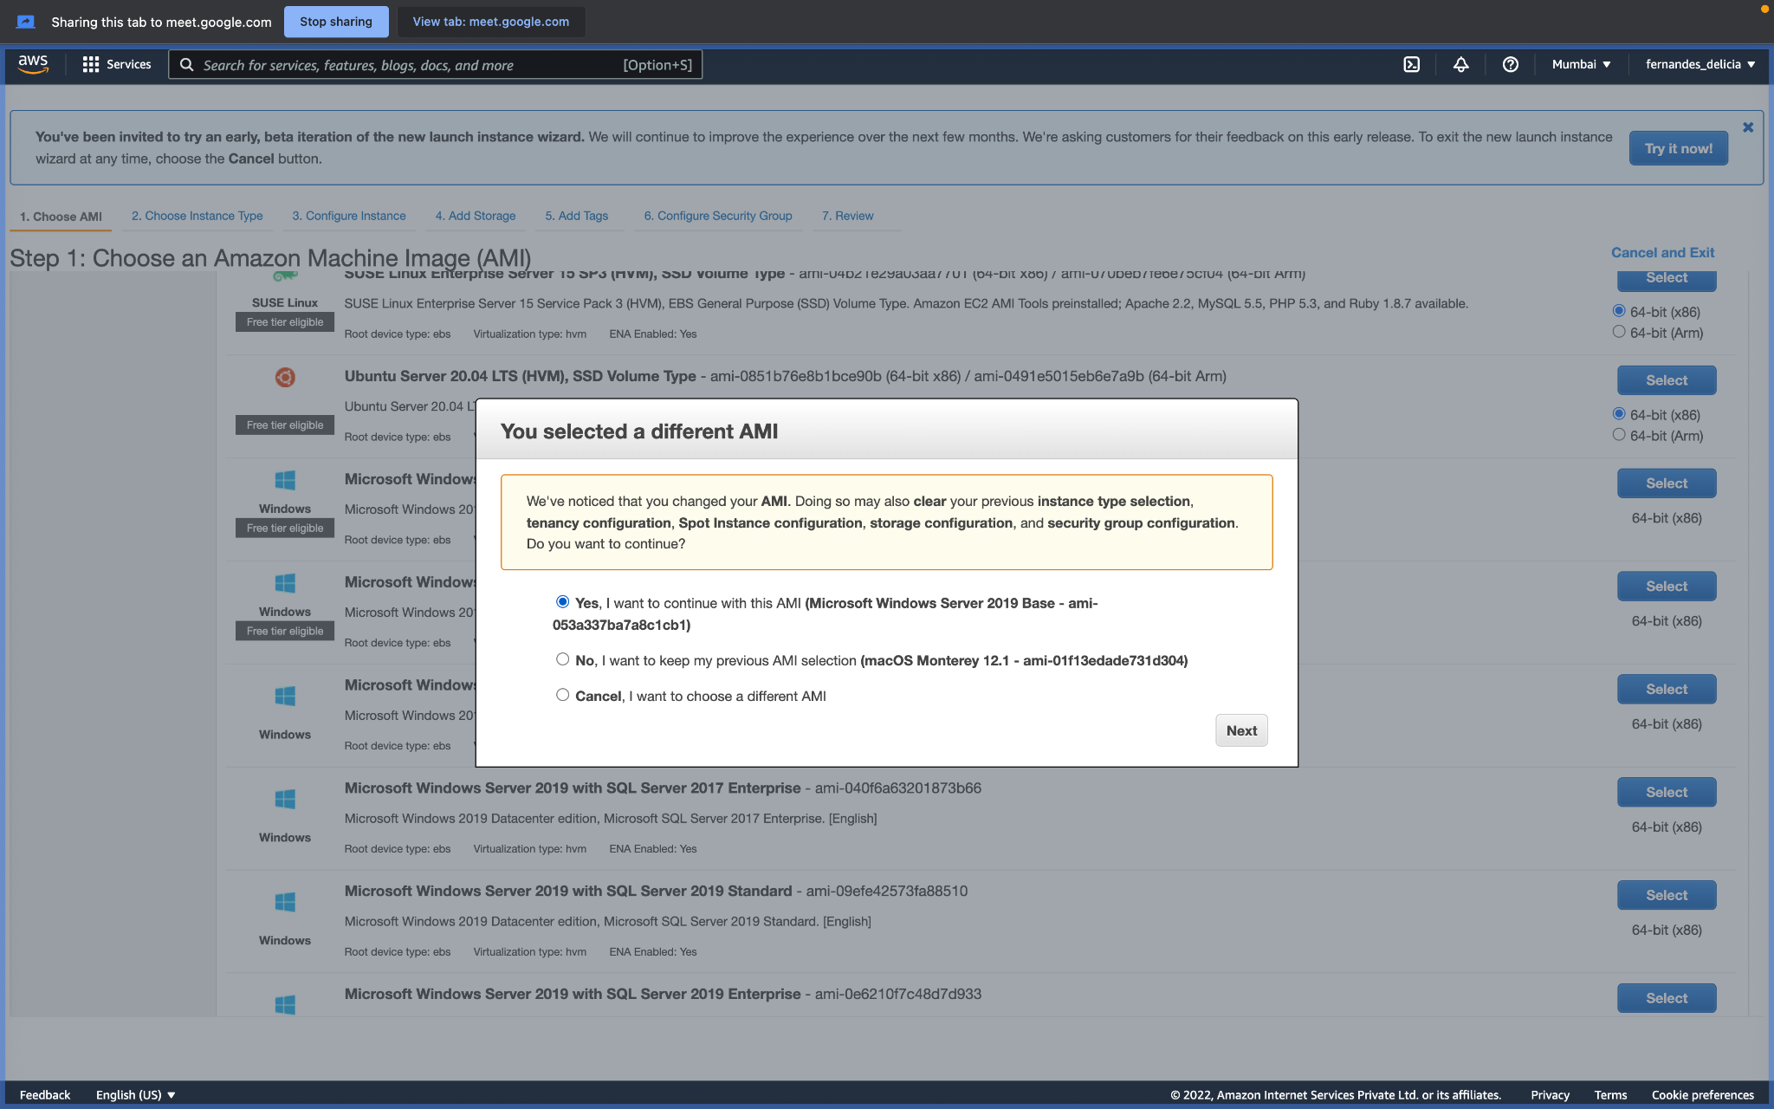

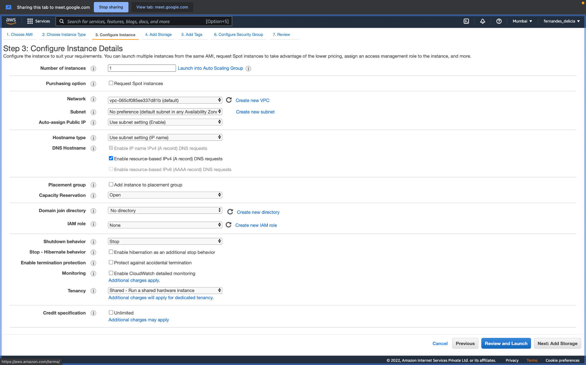

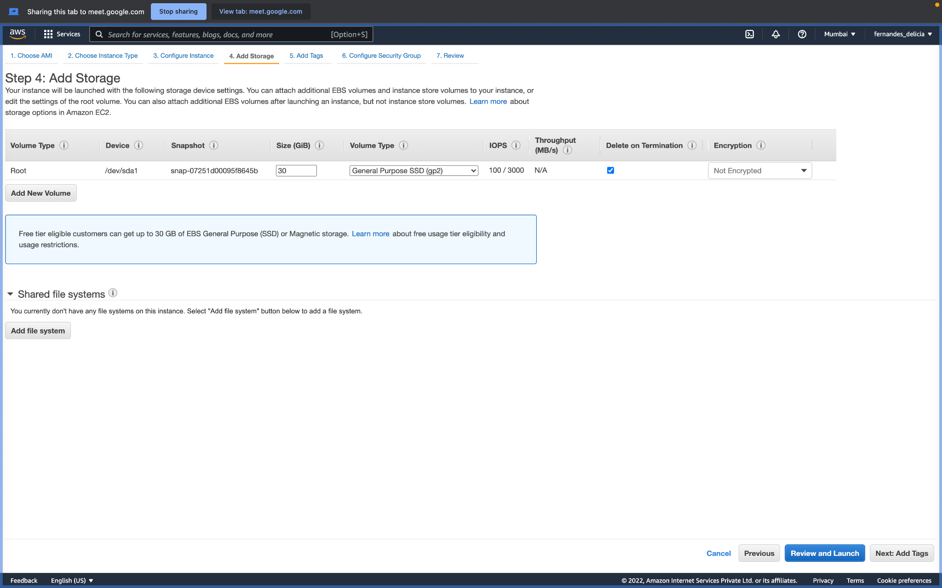

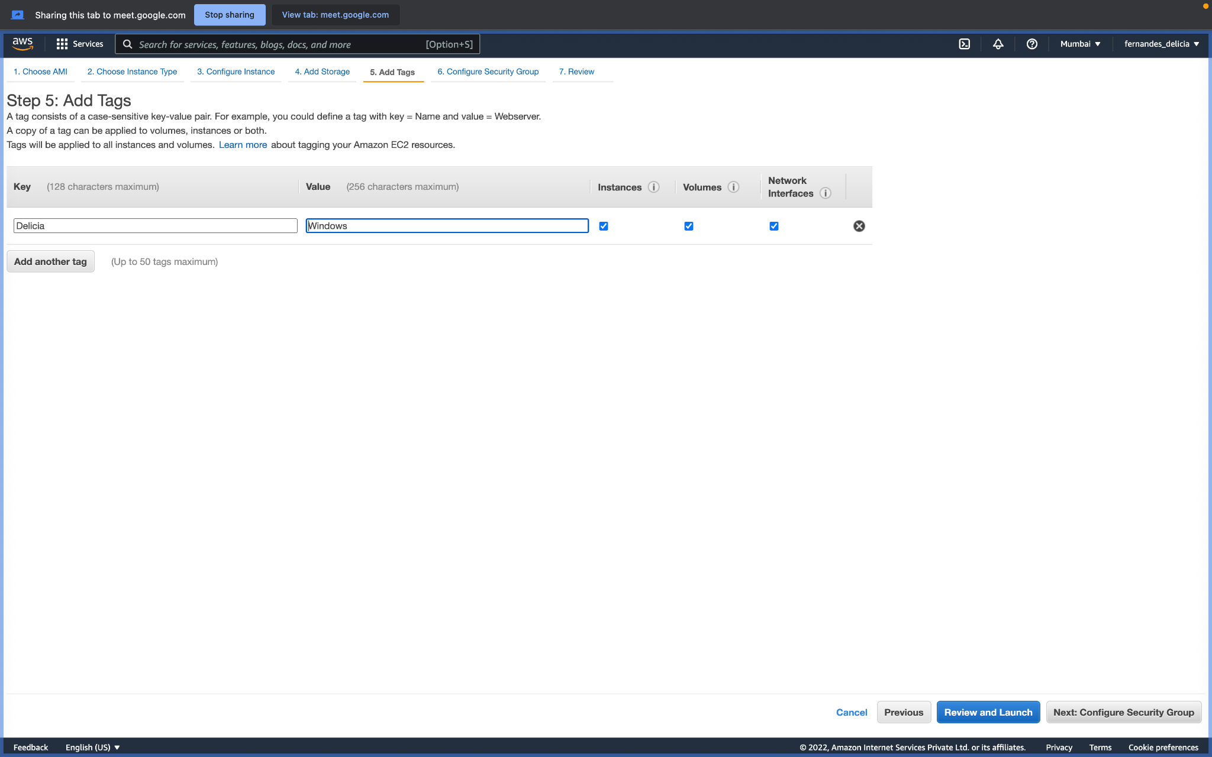

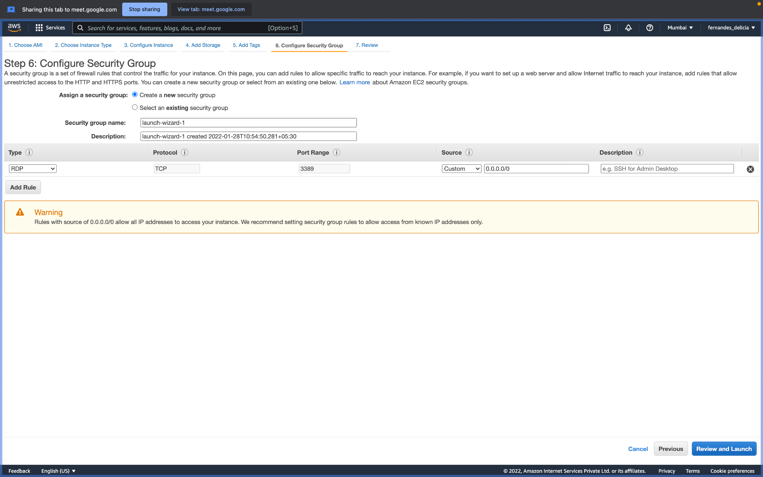

1. Download the rem file here, use it at the end

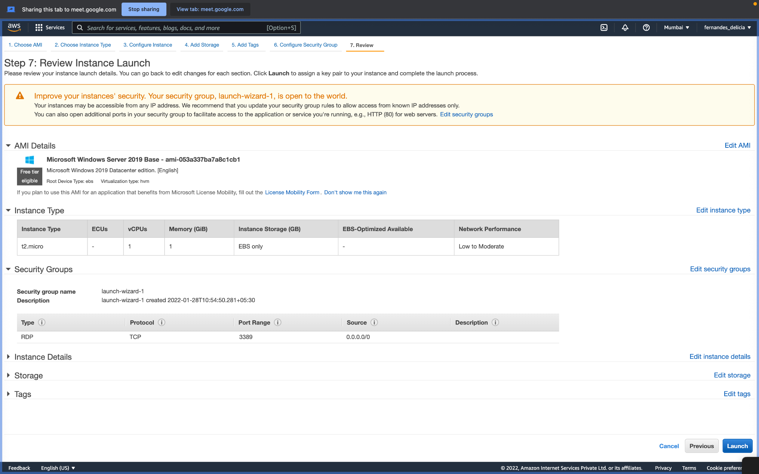

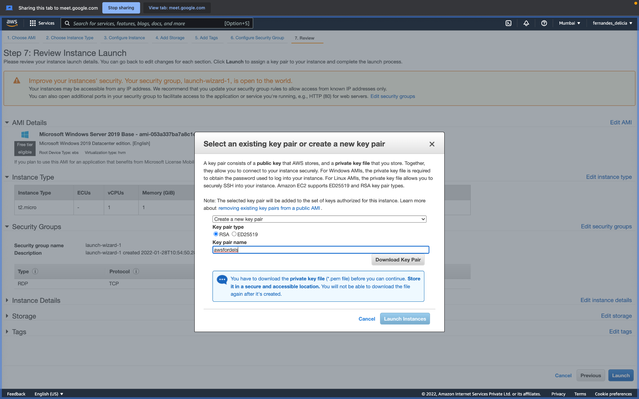

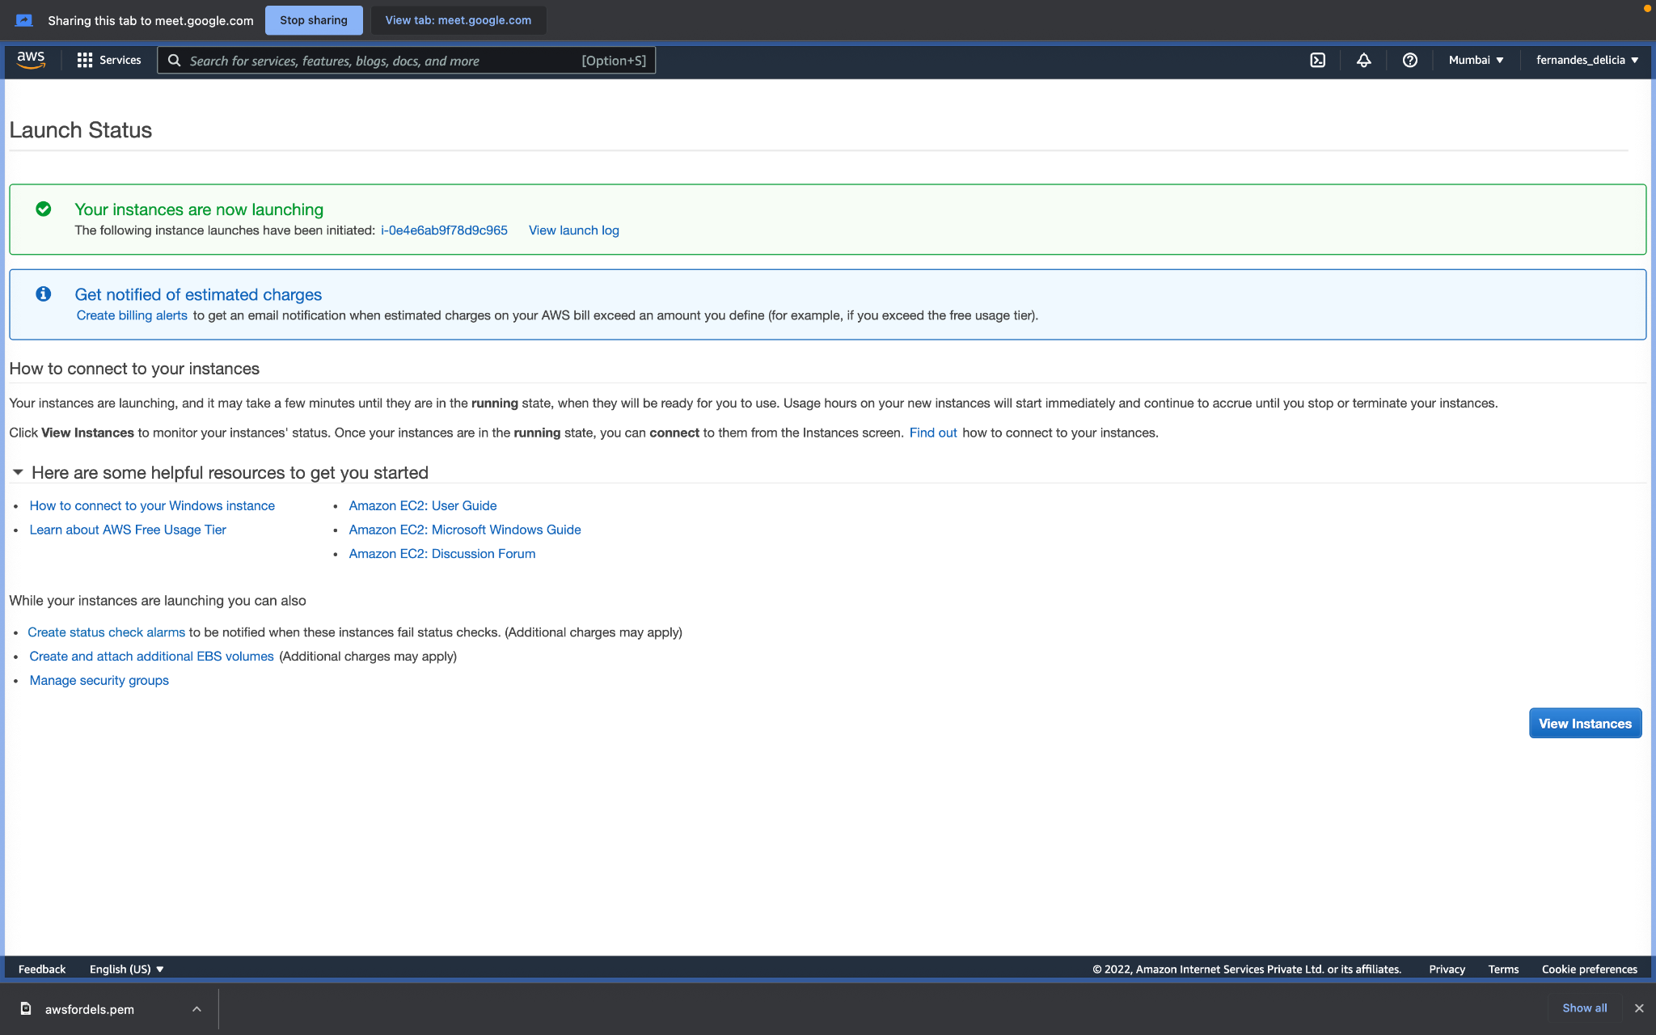

4. Wait for 2 mins, let it change from pending to running, then Click your instance here and click connect

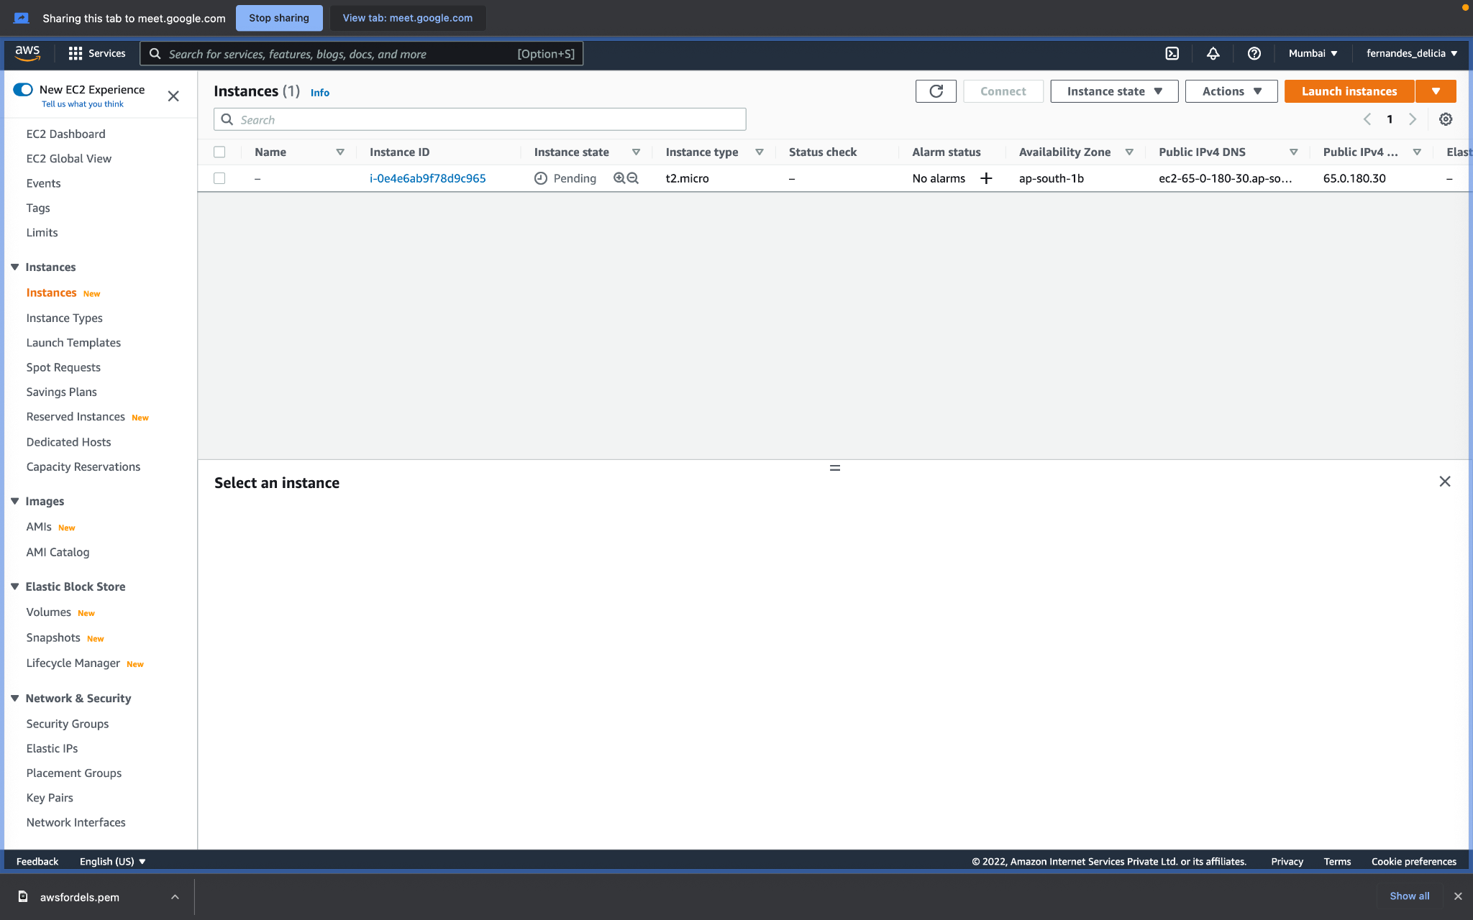

5. Download the rdp file here

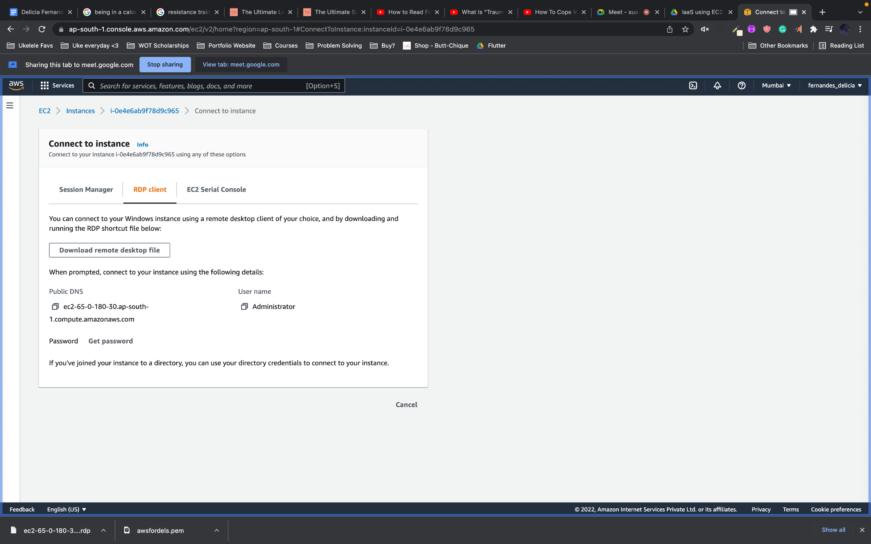

6. Upload the rem file here and decrypt

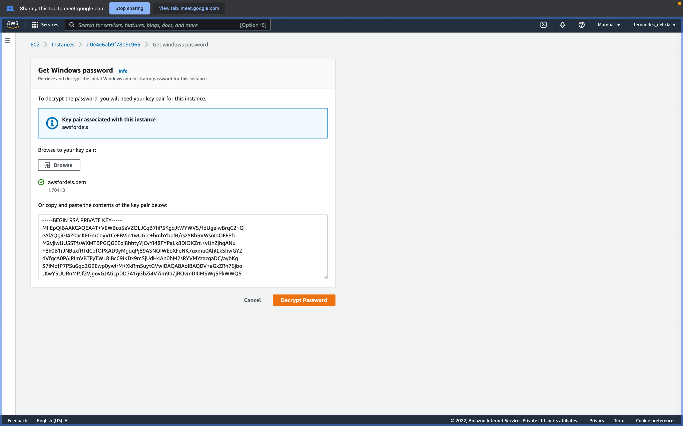

7. Copy this password and click on the RDP file on your local machine. Use the password there.

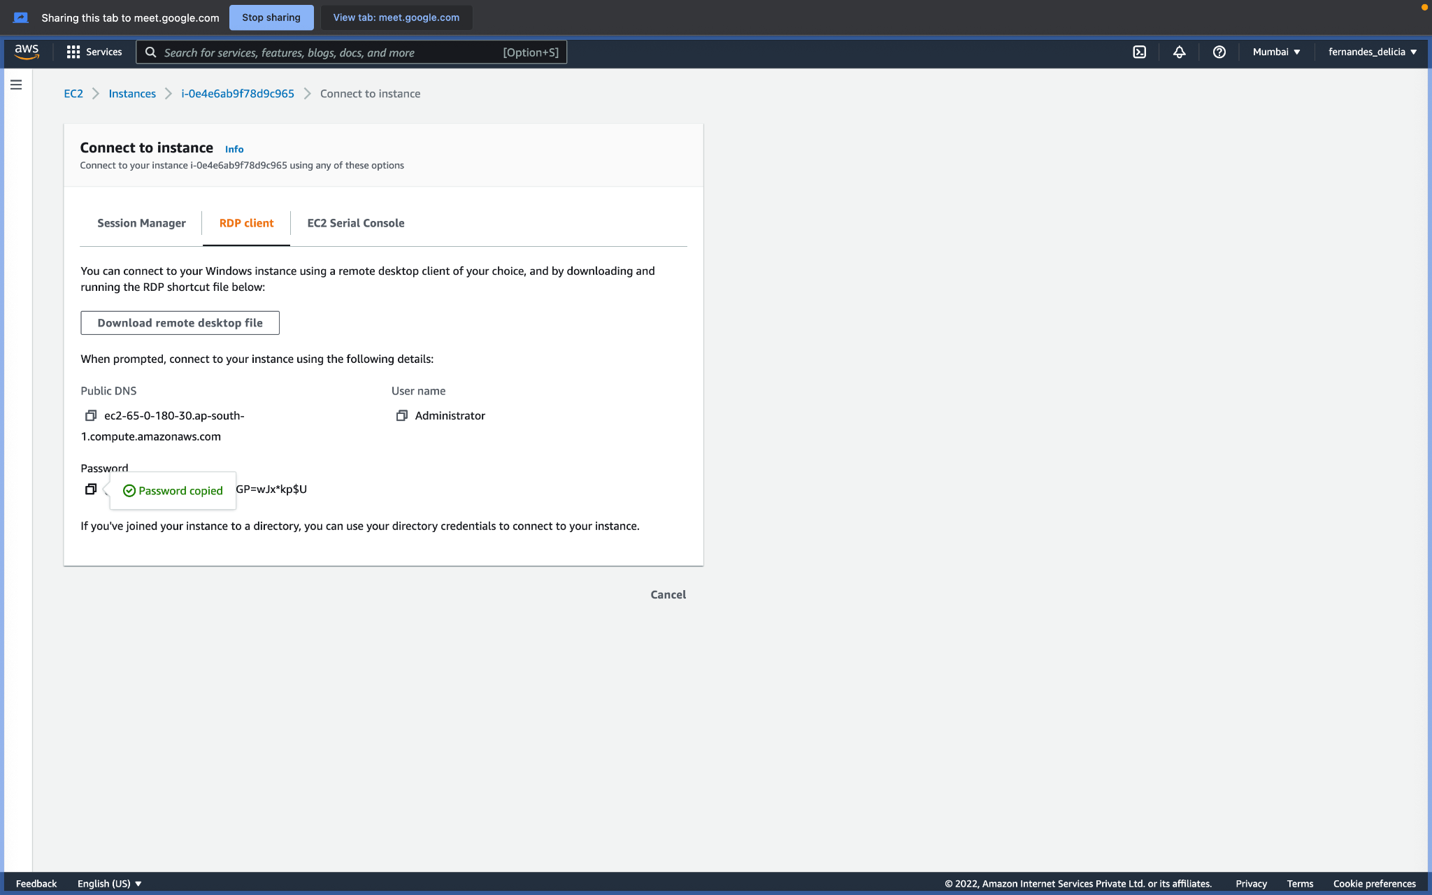

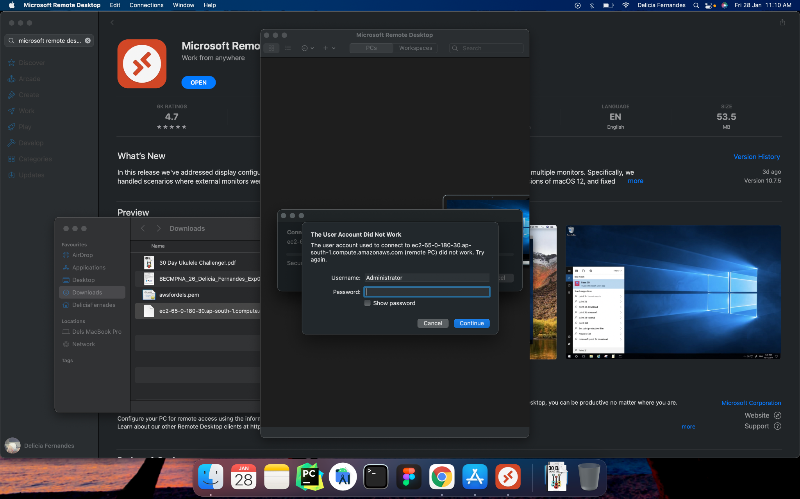

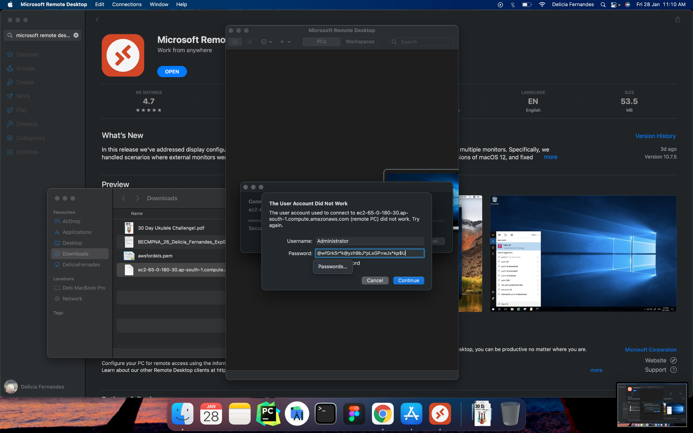





**Conclusion:**

What are the benefits of using IaaS?

Cost savings:

An obvious benefit of moving to the IaaS model is lower infrastructure costs. No longer do organizations have the responsibility of ensuring uptime, maintaining hardware and networking equipment, or replacing old equipment. IaaS also saves enterprises from having to buy more capacity to deal with sudden business spikes. Organizations with a smaller IT infrastructure generally require a smaller IT staff as well.

The pay-as-you-go model also provides significant cost savings. Because IaaS use is metered, organizations pay for only the capacity needed at any given time. This method also allows them to avoid large fixed monthly or annual fees for benefits they may not use. The IaaS model demands no upfront charges, bandwidth utilization fees or minimum term commitments.

Scalability and flexibility:

One of the greatest benefits of IaaS is the ability to scale up and down quickly in response to an enterprise’s requirements. IaaS providers generally have the latest, most powerful storage, servers and networking technology to accommodate the needs of their customers. This on-demand scalability provides added flexibility and greater agility to respond to changing opportunities and requirements. This is especially helpful in building and dismantling test and development environments, which greatly benefit from this increased speed and agility.

Faster time to market:

Competition is strong in every sector, and time to market is one of the best ways to beat the competition. Because IaaS provides elasticity and scalability, organizations can ramp up and get the job done (and the product or service to market) more rapidly.

Support for DR, BC and high availability:

While every enterprise has some type of disaster recovery plan, the technology behind those plans is often expensive and unwieldy. Organizations with several disparate locations often have different disaster recovery and business continuity plans and technologies, making management virtually impossible.

IaaS provides a consolidated disaster recovery infrastructure, reducing costs and increasing manageability. Frost & Sullivan research has determined that CIOs consider business continuity and preparing for disaster recovery the top drivers for adopting IaaS.

If disaster strikes, employees can access the same infrastructure they have always accessed via an Internet connection, from wherever they happen to be. This includes everything the organization needs to function as usual — email, web servers and critical applications. The result: quick recovery with no loss of data.

Focus on business growth:

Time, money and energy spent making technology decisions and hiring staff to manage and maintain the technology infrastructure is time not spent on growing the business. By moving infrastructure to a service-based model, organizations can focus their time and resources where they belong, on developing innovations in applications and solutions.

Benefits of IaaS Technology

* 1. [Increased Performance, Decreased CapEx](https://www.dataprise.com/resources/blog/iaas-benefits#One)
* 2. [Increased Security](https://www.dataprise.com/resources/blog/iaas-benefits#Two)
* 3. [Increased Scalability and Flexibility](https://www.dataprise.com/resources/blog/iaas-benefits#Three)
* 4. [Increased Support for Disaster Recovery and Business Continuity](https://www.dataprise.com/resources/blog/iaas-benefits#Four)

**References:**

[Infrastructure-as-a-Service: Benefits of IaaS Cloud Computing](https://www.dataprise.com/resources/blog/iaas-benefits)

[infrastructure-service-5-important-benefits](https://statetechmagazine.com/article/2014/03/infrastructure-service-5-important-benefits)

[IBM/lass](https://www.ibm.com/in-en/cloud/learn/iaas-paas-saas)

[Advantages and disadvantages of IaaS (Infrastructure as a Service) – Business Tech Planet](https://businesstechplanet.com/advantages-and-disadvantages-of-iaas-infrastructure-as-a-service/)